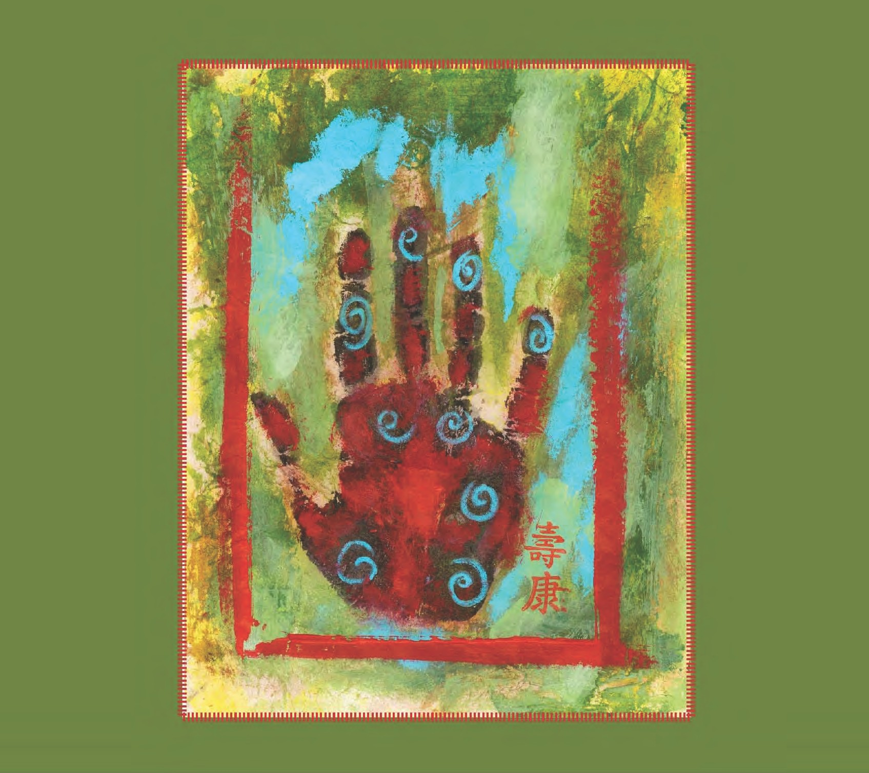

How To Thrive
In the Mod er n World
A LAYPERSO N'S GUIDE TO CHINESE MEDICINE

This publication is designed to provide competent, reliable, and useful information regarding the subject matter covered. It is sold with the understanding that the author and publisher are not engaged in rendering legal, financial, or other professional advice. The author specifically disclaims any liability that is incurred from the use or application of the contents of this ebook. The author does not warrant the performance, effectiveness, or applicability of any sites listed in this ebook. All links are for information purposes only and are not warranted for content, accuracy or any other implied or explicit purpose.

This manual contains material protected under International and Federal Copyright Laws and Treaties. You do have permission from the authors to forward this ebook to anyone you know who could benefit from the material. You do not have permission to use this ebook for marketing purposes or for display on a website without the prior written permission of Acupuncture Wellness Center of Coral Springs. For permission requests, email the author at info@AcupunctureCoralSprings.com or call 954-755-1292 .
Visit our website at www.acupuncturecoralsprings.com. Printed in the United States of America
Copyright 2010 by Dr. Jack Tobol, M.Ac., A.P. and Kevin Doherty, L.Ac.
All rights reserved
Permissions 2014 to Suzanne Swearengen, AP, DOM

Cover design and book format by Kat Macconochie, katzgrafix@hotmail.com

www.acupuncturecoralsprings.com

Table of Contents

Introduction page 3

Chapter 1
INVESTING IN YOUR HEALTH page 4

Chapter 2
THE MANY BENEFITS OF CHINESE MEDICINE page 7

Chapter 3
WHAT IS CHINESE MEDICINE AND HOW DOES IT WORK? page 9

Chapter 4
WHAT ARE THE DIFFERENT KINDS OF ACUPUNCTURE? page 16

Chapter 5
CASE STUDY page 20

Chapter 6
AN OVERVIEW OF CHINESE HERBAL MEDICINE page 23

Chapter 7
THE DOCTOR OF THE FUTURE page 26

About the Authors
page 30

www.acupuncturecoralsprings.com 2

Introduction
You have likely picked up this book because you are looking for ways to live a healthier, more balanced life. Maybe you have been struggling with your health and are in need of a new approach. If you are like most of our patients, you do not want to choose between being on medications for the rest of your life or suffering with nagging health problems. Instead, you want to live a life that is unlimited in its potential. You want to be full of energy. You want your body to be a symbol of vitality, strength, and longevity.

If you are fed up with not being able to enjoy the quality of life that you deserve due to various health problems, then the information in this book could change your life. Within these pages, you will learn about a fascinating ancient treatment method called Chinese medicine. This is an ancient form of healthcare that has been practiced for thousands of years and has helped literally billions of people. Our goal in offering you this information is to:

- Offer you a clear overview of this incredible healing system
- Give you a sense of empowerment that there are indeed natural solutions to your current health problems
- Encourage you to be proactive about your health and treat it as a top priority for the rest of your life

Having treated many patients with numerous health concerns, we know how frustrating and challenging it can be to struggle with chronic health issues.
We have learned that health problems are often warning signs from a very intelligent place within ourselves that we need to change our current way of doing things. Learning how to thrive in your life has a lot to do with learning from your health concerns, not just pushing them away or judging them as negative. This approach is, for many of our patients, where true healing begins. The information contained in these pages is your blueprint for a new way of understanding your body and mind.

If you have any questions or would like to pursue this form of healthcare, please refer to the end of the book on page 30 where there is information about our practice. Let’s begin!

www.acupuncturecoralsprings.com 3

Chapter 1

INVESTING IN YOUR HEALTH
When you think about it, there is nothing more important than your health. Even if every other dimension of life is going well (work, marriage, finances, etc.) we really can’t enjoy life if we are struggling with our physical or emo- tional health. Investing in and making a commitment to your health can feel like a big step to take, especially when we are conditioned to put everyone else’s needs before our own or to just ‘suck it up’ and deal with our stressful lives.

This is the starting point for learning how to thrive, as investing in your health is one of the most powerful steps you can take to dramatically enhance the quality of your daily life. It sets the stage for success in every dimension of life. When you have more energy, confidence, mental clarity, and improved physical health, you are more able to gracefully handle daily stressors and challenges that would have previously overwhelmed you.
Composure, control, and peace become the foundations of your life rather than isolated experiences.

Committing to and being proactive about your health in this way will lead to not only immediate improvement in your life, but will also set the stage for greater vitality and resilience as you age. In this way, there is a strong pre- ventative aspect to claiming optimal health right now. Most of us have been taught to put off our own needs until our bodies and minds are screaming at us for acknowledgment. We wait until we are given a wake up call that usually comes in the form of illness or worsening health problems.

But what if you were to be proactive right now? What if you decided to care for yourself enough to take the steps necessary to optimize your current state of health, thereby preventing future problems? What is preventing you from living a life of boundless energy and radiant health right now?

These are powerful questions to ask yourself. You see, most of us are caught in a constant game of negotiation with ourselves to buy more time to put off

www.acupuncturecoralsprings.com 4

the most important things in life. We think we have time to postpone our deepest needs for health, peace, and balance.

What we are getting at is that, in order to thrive in the modern world, it is essen- tial that you commit right NOW to your health as a top priority. This means:

- Partnering with the right holistic and allopathic (Western) medical practitioners
- Eating an organic whole foods diet
- Exercising 3-4 times a week
- Taking time each day to be present using relaxation techniques
- Freeing yourself of any limiting beliefs that undermine your health and quality of life

As with all important priorities in life, it is essential that you surround yourself with a community of people that can inspire and guide you in the direction of optimal health. We all need this kind of guidance or else we easily feel alone and confused. As you will see, a skilled acupuncturist can be an incredibly helpful resource in this regard.

Let’s summarize the main points here, then we will jump into an exploration of Chinese medicine and how it can help you achieve your health goals:

- Your health and quality of life depend on the choices you make every moment you are alive
- You can choose to claim a much higher level of health right now
- You do this by freeing harmful beliefs, establishing healthy lifestyle patterns, and allying yourself with a team of skilled holistic and allopathic medical practitioners
- NOW is the only moment we have; putting off your deepest needs will create bigger problems down the road

How do I know if I’m a good candidate for acupuncture treatment?

You would likely receive great benefit from this form of care if you are:

- Struggling with chronic health issues that haven’t responded to other forms of care
- Interested in reducing dependence on Western medications
- Looking for alternatives to conventional forms of treatment
www.acupuncturecoralsprings.com 5

- Seeking ways to optimize your health on all levels of being
- Fed up with the conventional healthcare model
- Looking for ways to grow spiritually and emotionally
- And perhaps the most important point: You are interested in taking responsibility for your health to make the changes that will create a life of greater balance and purpose

www.acupuncturecoralsprings.com 6

Chapter 2

THE MANY BENEFITS OF CHINESE MEDICINE

As we mentioned, Chinese medicine has been practiced for thousands of years and is used around the globe by millions of people. The reason that it has survived for so long and adapted to different cultures is that it offers a vast and potent repertoire of healing benefits that are so widely needed in our modern world.

You may have noticed that acupuncture has enjoyed an enormous surge of interest lately, as the media is really catching onto the widespread benefit that this treatment option is offering to so many people.

Just what are some of these benefits? Well, the list could expand over many pages, but here is a condensed version of what our patients are expressing and what clinical evidence is suggesting:

  - Substantial increase of energy
  - More restful sleep patterns
  - Less cravings, habitual behaviors, and addictive tendencies
  - Reduction or elimination of chronic stress
  - Emotional balance, increased joy and motivation
  - Increased mental clarity and memory
  - Improved athletic performance
  - Enhanced metabolism
  - Enhanced spiritual and emotional growth

Chinese medicine can effectively treat a number of chronic health problems, from anxiety and depression to chronic pain and PMS. The list of conditions treated by this medicine is vast to say the least.

Many people report a deep feeling of peace that stays with them for many hours or days after acupuncture treatment. Many patients find that this feeling of peace becomes the foundation for their life rather than an occasional experience.
www.acupuncturecoralsprings.com 7

Chinese Medicine is a holistic form of medicine

What is holistic medicine? Holistic means that the entire ecosystem of the body is taken into consideration when treating patients’ health. For example, if a patient comes in for abdominal pain the practitioner of Chinese Medicine would not approach the problem with a pill for the stomach. The patient would be carefully interviewed and examined. Lifestyle, constitution, sleep patterns and other signs and symptoms pointing at the source of the problem will be the focus of the treatment.

More time is spent talking to you to learn the more important information: what is leading to the stomach ache in the first place? A holistic practitioner will also consider your lifestyle, your body type, your sleep patterns, and they will typically look at your tongue and check your pulse. For this reason the diagnosis is tailored to the patient and you are likely to receive a treatment plan designed specifically for your type of stomach ache, flu, allergies, migraine.

www.acupuncturecoralsprings.com 8

Chapter 3

WHAT IS CHINESE MEDICINE AND HOW DOES IT WORK?

Chinese medicine is an ancient form of healthcare that has been practiced throughout the Asian world for 5000 years. Historically and up until this very day, Chinese medicine is perhaps the most widely used form of medi- cine throughout the world, as billions of people have used it as their primary form of care. There are five main branches of Chinese medicine (we will be covering the first two of these in some depth):

  - Acupuncture
  - Chinese herbal medicine
  - Nutrition
  - Qi gong
  - Feng shui

According to Chinese medical theory, these five branches form the founda- tion of a healthy and balanced life.

Acupuncture theory is premised upon the concept of Qi (pronounced Chee), which loosely translates as energy, life force, or function. The main point when trying to grasp the concept of Qi is to consider the possibility that there is an immaterial level of reality that Western science cannot quantify or categorize. Acupuncture theory suggests that many of our physical and emotional problems begin at a level of function that is more subtle than our brain chemistry or organ function.

Quantum physics has come to a very similar understanding of the material world and the human body by proving that when we break down any material object into its smallest components, it is reduced to pure energy. So, many of these ancient Eastern cultures have long understood what Western science is finally beginning to accept. Our bodies, while seemingly solid, are actually energetic configurations that are constantly changing. Acupuncture is premised upon this understanding. The point of treatment is to manipulate the flow of Qi within our bodies in different ways to induce a
www.acupuncturecoralsprings.com 9

therapeutic effect. By working on the energetic level, the physical or material level can be directly affected. In fact, according to acupuncture theory, many forms of imbalance or disease cannot be fully healed simply by intervening on the material level. The underlying energetic component has to be addressed in order to treat the root cause of the problem.

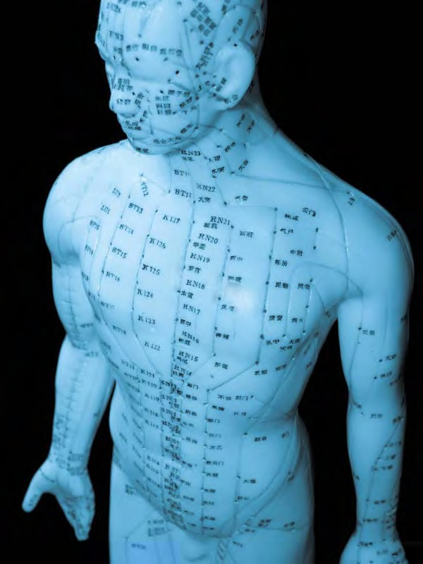
Now, according to acupuncture theory, the Qi in our bodies is said to pool and gather at specific locations that are spread out from head to toe. The specific locations where Qi gathers are called acupoints, or acupuncture points. These are typically the places where acupuncture needles are inserted to induce various therapeutic effects. There are approximately 365 basic acupoints on the human body. These numerous points are located on acupuncture meridians, which are channels of Qi that flow throughout the body. The meridians correspond to the major internal organs. Here is a list of the 12 major meridians that run through the body:

LUNG
LARGE INTESTINE SPLEEN STOMACH BLADDER KIDNEY
HEART
SMALL INTESTINE SAN JIAO PERICARDIUM GALL BLADDER LIVER

There are numerous acupoints on each of these 12 meridians. For instance, the Lung meridian has 11 acupoints while the Bladder Meridian has 67 acupoints. Each of these 365 points have names, metaphors, and images associated with them that help the acupuncturist utilize them in different ways. The meridians travel through specific regions of the body; they have definite origins and end points. Typically, an acupuncturist will insert tiny needles into a number of the acupuncture points on the meridians that are most in need of balancing.

www.acupuncturecoralsprings.com 10

What does the needle do?

Acupuncture should be a relatively painless, deeply relaxing experience. Many people are reluctant to pursue it because it involves the use of needles. Rest assured, a skilled practitioner can treat you with minimal, if any, discomfort. It is common for the patient to ask, ‘did you really just put a needle in?’ after it is inserted because the procedure is so gentle. Most patients are surprised by how little they feel as the needles are inserted. After the needles are in, there is typically a sensation of dull pressure or a mild achiness. Other patients report a feeling of tingling or warmth, while others feel a tangible and strong presence of Qi coursing through the body. In any regard, acupuncture should be a pleasant, tranquilizing, and safe experience. The needles are hair-thin and are used only once, then disposed into a biohazard container.

Most acupuncturists use stainless steel needles which are said to disperse energy and get the Qi moving effectively throughout the meridian that is being worked on. The needle is used as a medium for transferring and manipulating Qi in various ways. There are some acupuncturists who are so skilled at work- ing with Qi that they don't even need to use a needle to do so. They can simply use their hands or, even more remarkably, the power of their faculties of aware- ness, to induce the desired energetic shift that needs to occur for healing to take place. Most acupuncturists prefer to use needles, simply because this is the easiest medium to utilize for changing the energetics of the body.

In acupuncture theory, all of the major organs of the body are believed to work interdependently. This means, for example, that the function of your kidneys can have a direct impact on the function of your lungs. This is one example of the holistic nature of Chinese medicine. Western medicine tends to reduce the focus down to one isolated component without regard for how the organism is functioning as a whole. In acupuncture theory, all of our internal organs are part of an inseparable matrix of function; they all have important roles to play that directly influence the health of the other organs in the body.

Therefore, the acupuncturist can insert a needle into the Spleen meridian that will have a direct effect on the Heart meridian. Or, the acupuncturist can sedate or disperse Qi by using a point on the Liver meridian to help the kidneys function better. Other times, the acupuncturist works directly on the meridian that reflects the person's symptoms. For instance, acupuncture points on the Lung meridian can be used for treating asthma. How an acupuncturist chooses which points to needle is based on their training, expertise, and knowledge. It is
www.acupuncturecoralsprings.com 11

very likely that if a patient with a specific health condition were to see three different acupuncturists, they would receive three unique styles of treatment, all of which could effectively address their presenting health issues.

Many acupuncturists assert that the ritual of needling specific points is primar- ily a way of making therapeutic suggestions to the body. It is like offering the body some new input to work with so it can disentangle itself from the feedback loop and habit of chronic pain, imbalance, or weakness. Our bodies are miracu- lous self-healing organisms. When prompted and guided in the right way, the body has the amazing ability to heal itself. This is what all forms of holistic medicine intend to induce: A non-invasive, gentle, yet potent method of inter- vention that naturally offers to the body what it needs to heal itself.

Inserting a needle into an acupuncture point is a way of communicating with the patient's body. It is like saying to the body, "WAKE UP! " or "relax..." In fact, there are a number of intentions and suggestions that a skilled acupuncturist can utilize when working on a patient. Acupuncture is much more powerful when the intention of the practitioner is transmitted through the needles. In this sense, the needles can absorb this intention and penetrate the barrier of the patients’ skin. This is one of the most fascinating dimensions of this form of treatment. There are numerous occasions where patients directly feel energy shift in their body and seem to awaken to the intention that has been created prior to insertion of the needles.

As with all forms of holistic treatment, Chinese medicine begins with the theory that every human being has an innate resource of wisdom, strength, and health that can be tapped into at any moment. Acupuncture is a way of making contact with this incredible resource. In this sense, it emphasizes the truth that each of us must be held accountable for our health and quality of life. If life circumstances have caused us to feel alienated from this inner wisdom, then we can certainly turn to acupuncture as a way to reconnect with ourselves and awaken to our full potential. But acupuncture is not intended to be a cure-all for our health problems nor is it a magic bullet that will make all of our pain go away. A skilled acupuncturist will engage in a therapeutic relationship with the patient to help educate them about how they can take responsibility for their symptoms or imbalances.

This approach is very different from Western medicine in which the patient is typically offered a pill to suppress or alleviate their symptoms. While allopathic care is certainly warranted for acute and life-threatening conditions, it fails at
www.acupuncturecoralsprings.com 12

truly offering a deep level of support to the millions of patients with chronic, stress-related issues like anxiety, insomnia, pain, and digestive disorders. By putting the responsibility and power in the hands of the patient through effective education and treatment, Chinese medicine is mainly intent on treating the root cause of our health conditions.

Now, this does not mean that you have to believe in these techniques for them to work. It does mean that you have to believe in yourself to reap the full benefits that these strategies have to offer.

We have already touched on the fact that Chinese medicine is one of the few truly holistic medical traditions in the modern world. What does this mean exactly? Well, a skilled acupuncturist looks at health and illness differently than does a typical Western doctor. A holistic form of care is one that focuses on:

- The effects of the mind (beliefs, perceptions, attitudes) on the human body
- The role that nature plays in health and disease
- The relationship between emotional and physical health
- The subtle ways that energy is distributed through the human body
- The energetic processes that underlie physical and emotional imbalances

When we normally think of holistic medicine, we think of the connection be- tween body, mind, and spirit. While this is certainly one dimension of any truly holistic paradigm, holism implies a much broader usage as well. For instance, when diagnosing your various health issues, the acupuncturist will look at:

- The relationship between your beliefs and predominant emotions
- Physical imbalances that may be contributing to emotional hardship
- Dietary habits
- Exercise habits
- The degree to which you are engaged with and loving your work
- Social support systems
- Spiritual awareness
- Intimate relationships

All of these factors are potential inputs into your current level of health. From a holistic perspective, anything that we have attracted into our lives that strength- ens the momentum of our current health issues needs to be considered as a
www.acupuncturecoralsprings.com 13

potential avenue for therapeutic intervention. In this sense, a skilled acupunc- turist often is seen as a health or life coach as much as they are a healer or a doctor.

The beauty of holistic medicine is that it truly does account for your individual and unique makeup. For instance, you may have noticed in Western medicine that there are three or four medications that are used for all kinds of anxiety and depression. Prozac, Paxil, Effexor, etc. are standard treatment options regard- less of the patient's specific energetic, physiological, and emotional makeup. In holistic medicine, anxiety and depression are considered generic labels that do not capture the unique dynamics of the individual. For instance, one person can experience a grief-based depression due to the loss of a loved one while some- one else is depressed because they are internalizing a lot of anger and don't know how to express themselves. In Western medicine, these two very different patients would likely receive the same medication. In holistic medicine, there are entirely different approaches used to complement the specific emotional dynamics of the patient. Grief and anger are very different emotions and need different therapeutic inputs in order to be liberated. In this sense, holistic medicine really does treat the person, not the disorder.

Chinese medicine asserts that the body mirrors the mind. To the extent that we are spiritually embodied and free of distorted beliefs, our bodies will thrive.
Contrarily, gradual physical decline is the result of attachment to limiting view- points that suppress the spirit. Many people blame their failing health on the aging process. From a holistic perspective, chronological age has very little to do with the health of the physical body. The reason that the body tends to decline as we age is because of the chronic and stubborn nature of our condi- tioned beliefs and habits. If we choose to enable these beliefs to run our lives year after year, rest assured the body will inevitably undergo a process of degeneration that can be gradual or sudden. The body becomes less tolerant of imbalanced perceptions and behaviors over time. This is the main reason that age-related physical issues become apparent. This is accounted for by the many elderly people in the world who have maintained a state of thriving physical health that seems to defy their actual age.

The life force of the human spirit is what animates the body and provides its deepest source of nourishment. If this is blocked by difficult emotions, the body will be vulnerable to a process of more rapid deterioration, even if one eats a healthy diet and thinks that they take good care of themselves. Chinese medi- cine is a way of making suggestions to the body/mind to release any blocks to
www.acupuncturecoralsprings.com 14

one's spirit so that this deep source of health and well-being can finally be accessed.

What can I expect during treatment?

Many patients have been amazed by the sensations they feel during treatment, as if their body is pulsating with a pleasant electrical current that they have never felt before. Acupuncture helps people feel their internal energy. It gets them out of their head and restores a kind of intuitive connection with the body. Acupuncture has a way of dropping one's attention deep into the body to feel the subtle currents of sensation that are created by the movement of Qi.

Many people also describe how quickly the acupuncture session goes by. Even though they had been laying on the table for 45 minutes, they literally feel that only 10 minutes have passed. This happens because acupuncture has a way of taking people out of linear time. As the patient's awareness becomes more body
-oriented, the normal thought process of cause and effect ('I have to make that meeting at 12') falls away, and a sense of timelessness ensues. This alone can be a profoundly healing experience.

If you try acupuncture, you will very likely fall asleep or simply sink into a deep relaxation. For the rest of the day (and possibly for several days after that), you will feel energized and refreshed, as if your body has just gone through a period of deep rest.

www.acupuncturecoralsprings.com 15

Chapter 4

WHAT ARE THE DIFFERENT KINDS OF ACUPUNCTURE?

While a detailed analysis of the history and theory of acupuncture is beyond the scope of this book, it is important to know that there are two main traditions of acupuncture used throughout the world. The first one is called eight principle acupuncture, which involves harmonizing imbalances that have developed in the body. The eight principles refer to:

  - Interior
  - Exterior
  - Hot
  - Cold
  - Excess
  - Deficient
  - Yin
  - Yang

An eight principle acupuncturist will use these parameters to assess the relative degree of balance within the patient’s body. For instance, a patient can have a deficiency of yin, which means that the calming, moistening, and cooling aspects of their physiology have become depleted. In this case, the acupuncturist will nourish yin in order to calm and cool the patient.

Eight principle acupuncture is the predominant form of treatment in the modern world. Most acupuncturists are trained in this manner. It is an effective way to clear out various symptoms by harmonizing their underly- ing imbalances. This style of treatment is widely regarded as being able to quickly offer symptomatic relief. Many acupuncturists rely on it for treating pain-related concerns such as frozen shoulder, headaches, low back pain, and sprains and strains. Eight principle acupuncture can often be used to reduce or eliminate pain medications. It has no side effects and is considered a very safe and effective form of treatment for both chronic and acute pain.

Eight principle acupuncture can also be used for internal medical conditions,

www.acupuncturecoralsprings.com 16

as it exerts a harmonizing and balancing influence on the internal organs and the major systems of the body. While it is certainly useful for chronic health issues, many acupuncturists also utilize five element acupuncture, the second style of treatment, for this purpose.

Five element acupuncture has its roots in pre-Communist Chinese medicine. This tradition was born out of a cultural viewpoint that embraced the powerful reality of the invisible world and the effect that Qi and the emotions can have on our physical health. According to the five element model, every human being has a constitutional type that is created at the moment of conception that is aligned with one of five elements: earth, metal, water, wood, and fire. Each of these elements has within them specific associations that are found throughout the natural world. As such, there is a color, sound, odor, emotion, season, and belief system ascribed to each of the elements. Below is a basic chart that will help you to understand the associations of each element:

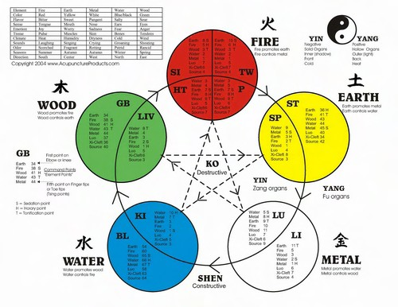

www.acupuncturecoralsprings.com 17

EARTH
Emotion: sympathy, rumination, obsession Color: yellow
Season: late summer Sound: singing Odor: fragrant
Distorted belief: 'I am not enough; therefore, I must put others or myself first in all situations.'
Earth in Balance: Feeling complete right now, genuine selflessness, balance between giving and receiving

METAL
Emotion: grief, longing Color: white
Season: fall Sound: weeping Odor: rotting
Distorted belief: 'Life has no value and is meaningless; therefore, I must attach to the material world or renounce it altogether.'
Metal in Balance: Inspiration, value, poignancy, being present to life

WATER
Emotion: fear, anxiety Color: blue
Season: winter Sound: groaning Odor: putrid
Distorted belief: 'My purpose is not powerful enough to change the world. I am subject to the whims of fate.'
Water in Balance: Purpose and potential fulfilled, feeling the fear and doing it anyway, power

WOOD
Emotion: anger, frustration Color: green
Season: spring Sound: shouting Odor: rancid
Distorted belief: 'Life isn't fair. I am resigned to a life of injustice.'
Wood in Balance: Creativity, broad perspective, benevolent, visionary

www.acupuncturecoralsprings.com 18

FIRE
Emotion: sadness or lack of joy Color: red
Season: summer Sound: laughing Odor: scorched
Distorted belief: 'Life isn't safe. It's impossible to find real intimacy.' Fire in Balance: Charisma, joy, connection, compassion

According to the five element model, every one of us is predominantly affected by one of these elements and their associations.

Using the wise guidance of this model, we can see how there are precise psychological dynamics at work that perpetuate our physical health problems. As these psychological dynamics are allowed to persist, the five element model clearly shows us how physical pathology will eventually result.

Clearing Shock

The first priority in treatment using five element acupuncture is taking the patient out of a state of shock. While most of us think of shock as an overt trauma or accident that would lead to post traumatic stress disorder (PTSD) or something of the like, shock can be much more subtle in its cause and manifes- tation. From this perspective, we can define shock as the loss of awareness of present moment reality. This kind of shock leads to many chronic health problems, as the body will eventually mirror the mind. Using various five element acupuncture protocols, the blocked energy of shock can usually be cleared either instantly or within a few weeks of treatment. When this happens, the patient will typically say something like, 'I feel like my old self' or 'I feel like I have myself back.' These are classic statements that show the shock has cleared.

Five element acupuncture suggests that the majority of the people in our society is in this kind of low grade shock. We are surviving, but we are not thriving.
We are able to function and make it through the day, but we are not deeply connected with our purpose and living from a place of spirit. This is why 40 million Americans have been diagnosed with anxiety and depression and why countless more carry chronic and extreme amounts of stress, pain, insomnia, and hormonal imbalances.
www.acupuncturecoralsprings.com 19

Chapter 5

CASE STUDY

The following is a case study that captures the relationship between a pa- tient's physical, emotional, and spiritual dynamics.

Jenny, a 52 year old woman, came in with the initial complaints of fatigue, low back pain, dry and burning eyes, thirst, insomnia and digestive weak- ness (characterized by bloating, constipation, sluggish metabolism, or diar- rhea). These symptoms had persisted for four years and were steadily get- ting worse. While she did not explicitly state that she was anxious or depressed, it was clear that she would easily be clinically diagnosed as suf- fering from both of these maladies. A recent series of tests performed by a rheumatologist had led to a tentative diagnosis of Sjogren's syndrome, an autoimmune disorder characterized by extreme dryness, insomnia, and joint pain.

Jenny was extremely worried about her health. In particular, she mentioned several times that she was terrified of having a heart attack. Even though her blood pressure and cholesterol were within normal limits, she could not stop obsessing about the health of her heart. It was clear that Jenny felt extremely victimized by her health issues. She would repeatedly ask, 'why me?' and 'why do I have this back pain again and again?' She desperately wanted someone to understand all that was happening to her and to sympathize with her unfortunate plight in life. These signs, along with her yellow facial color, and sweet disposition, confirmed that Jenny was an earth constitution.

After a few acupuncture treatments, it was evident that Jenny was on her way to better health. There was more light in her eyes, she was laughing more, and she was generally more light-hearted. She was not complaining as much about her aches and pains. During one particularly powerful treatment, Jenny finally arrived at the core belief system that had sabotaged her emotional and physical health:

'I am only good enough when I work my hardest to please other people. Rest

www.acupuncturecoralsprings.com 20

is for lazy people.'

Jenny had been a victim to this core belief for the better part of fifty years. She had never given herself permission to deeply rest, relax, and enjoy life. Instead, she worked too hard, always putting other's needs before her own. All of her symptoms were clear messages that her mind was working against her body (which is common in autoimmune disorders). This belief was slowly killing her.

After identifying this constitutional imbalance, she said, 'Well, I guess I'm going to have to work on getting rid of that.' In reality, her attempts to 'work on' this issue would only provide more struggle for her. After all, it was her 'working on' every aspect of life that had slowly eroded her physical health. Instead, it was suggested to her that she liberate the energy of this belief right now and allow it to be effortless. This struck a deep chord within her as she said, ‘You mean I really can do that?’ A look of relief washed over her as she made her way to the treatment table. A few acupuncture points were chosen that captured the essence of this profound shift. To give you a sense of how five element acupuncture works, the names and functions of the points have been included here:

Stomach 40 Abundant Splendor: Restores a sense of wholeness and completion Stomach 8 Head Tied: Relaxes the mind's tendency to obsess and worry Spleen 3: Strengthens the basic ability to receive nourishment from life
Heart 7: Transmits this nourishment directly into the heart

Jenny's constant worry about her heart was actually a way of expressing her awareness that her heart was not open to her life. She simply mistook her literal heart for the suppressed nature of her Shen (the spirit of the heart that expresses one's deepest source of wisdom to the world). Her homework assignment after the treatment was to take the next two weeks to do nothing but completely relax and nourish herself, to give herself permission to restore her lost health.

This case study can give you a sense of how acupuncture can help someone deeply heal both the mind and the body. Immediate and profound change can result from identifying the core dysfunctional belief system reflective of one's constitutional type and then needling acupuncture points to balance the Qi that supports that belief system. This is why acupuncture can be so helpful for a myriad of chronic health problems. It can address the underlying energetic imbalance that sustains our health problems. When this level of treatment is
www.acupuncturecoralsprings.com 21

effectively addressed, one's overall health and life begin to feel much better. In this way, acupuncture can simultaneously heal the mind (anxiety and depres- sion) and its correlative physical imbalances (joint pain, digestive problems, shoulder tension, headaches, etc.) As such, the entire pattern of disharmony has been resolved simply by balancing Jenny’s Qi.

www.acupuncturecoralsprings.com 22

Chapter 6

AN OVERVIEW OF CHINESE HERBAL MEDICINE

As one of the main branches of Chinese medicine, Chinese herbs have also been used for thou- sands of years to help in the healing of physical and mental disorders. Many people find herbs to be an attractive treat- ment option because, if they are used skillfully, they are gener- ally free of side effects. Herbal medicine supports and enhances one's overall health.

A Chinese herbalist is more interested in strengthening the foundation of one's health rather than offering symptomatic band-aids. In this sense, herbal medicine works from the inside out; it treats the core issues that underlie our symptoms, which will either sooner or later rectify the symp- toms themselves. This is in contrast to Western drugs which work from the outside in. They offer immediate symptomatic improvement without directly addressing the deeper cause of the symptoms. While there are certain cases where this is warranted, the long-term use of Western drugs for chronic health problems can be detrimental to one's foundation of health.
This is why it is often best to pursue plant-based medicines and nutrition before going the drug route. It is a more gentle, life-affirming way to heal yourself.

Chinese herbalists generally use the Chinese herbs in various combinations to make up formulas for the patient. A talented herbalist can combine several herbs to offer a highly specific form of treatment to the unique needs of the patient. Herbs are quite versatile. One formula can have ingredients for treating depression and all of its byproducts such as pain, insomnia, or menstrual problems. When the underlying pattern of disharmony is
www.acupuncturecoralsprings.com 23

addressed, all of the symptoms associated with that pattern should improve.

In regards to physical health complaints, Chinese herbs can be used for a wide range of conditions including:

- Chronic pain
- Diarrhea
- Constipation
- PMS
- Menstrual cramps
- Weak immunity
- Asthma
- Headaches
- High blood pressure
- High cholesterol
- Type 2 diabetes
- Infertility

When it comes to treating the mind with Chinese herbs, it has long been recog- nized that there are numerous herbs that offer direct benefits for our emotional and psychological health. Everything that we ingest as food or medicine affects the mind in some form or another. Sometimes, however, it is too subtle to detect. When certain herbs are concentrated and given at a sufficient dosage, there can be tangible effects on one's consciousness. Chinese herbal formulas that work on the mind can:

- Make you feel psychologically lighter
- Relax and calm your thoughts
- Open your perspective on yourself and life
- Engender patience and calmness
- Boost confidence levels
- Induce more peaceful sleep

Chinese herbal medicine is widely regarded as a wonderful complement to acupuncture treatment. Many practitioners use Chinese herbs as a way to offer continual therapeutic input into the body between acupuncture treatments. By taking herbs on a daily basis, the positive momentum created by acupuncture is enhanced.

www.acupuncturecoralsprings.com 24

Can Chinese herbs be taken with my Western medications?

In many cases, yes. When you visit your practitioner, be sure to mention any medications you are taking and ask them about drug/herb interactions. There are situations where the herbs will antagonize Western medications, but in most cases herbs are safe to use with medications as long as they are prescribed by a skilled herbalist.

Along with acupuncture and Chinese herbs, Chinese medicine asserts that dietary therapy, exercise, and the healing of our environment also play crucial roles in our overall health and quality of health. In order to thrive, we want every piece of the puzzle to be acknowledged and working for us. Many acupuncturists will be able to help you develop a nutritional plan that reflects your unique constitutional needs. They may even show you various breathing exercises or Qi gong (a meditative form of movement) exercises that will enhance your treatment experience.

www.acupuncturecoralsprings.com 25

Chapter 7

THE DOCTOR OF THE FUTURE: A RETURN TO THE LAWS OF NATURE

"The doctor of the future will give no medicine, but will interest his patients in the care of the human body, in diet, and in the cause and prevention of disease."
~Thomas Edison

One of the primary goals of holistic healthcare practitioners such as acupunc- turists is educating patients on lifestyle choices so they don’t become dependent on Western medications. Western medicine is miraculous in its ability to treat certain kinds of health concerns. Its ability to deal with condi- tions such as broken bones, life-threatening injuries, and severe infections is outstanding. These acute conditions are where traditional Chinese medicine is often limited. (Chinese medicine is very good for some acute conditions such as acute pain and childbirth, but usually works best when its more subtle methods have time to work.)

On the other hand, traditional Chinese medicine is very good at treating
chronic problems.

Whether it’s chronic insomnia, digestive problems, fatigue, menstrual issues, or emotional imbalances, the goal of Chinese medicine is to gently bring your system back to a state of dynamic balance. When this is done skillfully, there are no side effects or risks associated with the treatment.

This is why traditional Chinese medicine is called complementary medicine. It complements Western medicine's strength with acute problems by treating chronic problems that Western medicine can only hide. So when considering what treatment to seek, you may want to determine whether Western medicine will actually help the condition be resolved, or only make it tolerable. While Chinese medicine cannot treat every chronic condition, it usually can help.

www.acupuncturecoralsprings.com 26

What’s Wrong with Using Pharmaceuticals for Chronic Health Issues?

Most of us think of drugs as safe and effective. We hear about "wonder drugs" and are told such things as "take one and call me in the morning." Often these medications help to control symptoms, but they do have a dark side.

According to a study published in the Journal of the American Medical Association (JAMA) in 1998, deaths due to legal drugs in hospitals were the fourth leading cause of death in the United States. Notice that this study only covered deaths in hospitals – the very place to be if you're near death. These deaths occurred even with ready access to doctors. Dr. Jay Cohen, in his book Overdose: The Case Against Drug Companies explains that this study is actually very conservative:

Because of the especially rigorous methods the researchers applied, even these numbers may not present the full picture. The authors defined serious side effects narrowly, including only clear-cut reactions causing permanent disability, hospitalization, or death. Thus, they excluded side effects that disable people for weeks or months, side effects such as dizziness or sedation that cause automobile accidents or falls and broken limbs, side effects that require emergency interventions, and side effects that prolong hospitalizations or force people to miss work. And the authors didn't even try to count the largest category of all: side effect occurring in outpatients. Overall, they excluded side effects that occur far more often than the ones they included.

Despite omitting so many side effects, the JAMA study still recorded numbers reaching epidemic proportions. And, as the authors noted, this side effect epidemic wasn't new: "The incidence has remained stable over the last 30 years." (p. 3)

The problem is probably worse now, since this book was written in 2001. Since then, drug companies started to advertise extensively on TV. The drugs that are advertised are the newest drugs; by definition they're the least understood and therefore the most dangerous. As a well-known pharmacology textbook notes:

"51% of approved drugs have adverse side effects not detected prior to approval."1

The side effects of new drugs are discovered over time. In fact, the Physician's Desk Reference, which is used by nearly all doctors as a reference to medications, consists mostly of descriptions of drug side effects.

In fact, "All drugs have side effects, and even the safest approved drugs have side effects," according to Dr. Janet Woodcock, the director of the FDA's Center
www.acupuncturecoralsprings.com 27

for Drug Evaluation and Research2. Even Eli Lilly, founder of the $58 billion Eli Lilly and Co. pharmaceutical company said:

"A drug without side effects is no drug at all."

Because of these side effects, drugs are often far from safe. Chinese medical theory explains why.

In traditional Chinese medicine, health conditions are believed to be due to an imbalance in the body. Modern drugs control symptoms by interrupting biochemical pathways that would otherwise cause pain, discomfort or other symptoms. However, the original imbalance in the body's systems is still there, and just masked by the medications.

In other words, drugs don't actually heal any conditions. They only hide them and make them tolerable. The only exceptions seem to be chemotherapy drugs and antibiotics.

Acupuncture and traditional Chinese medicine work by helping bring your body's systems back into balance. When that happens, natural healing mechanisms take over.

There's actually no way that healing can come from anywhere but within the body. A surgeon may make an incision, but without the natural healing ability of the body, there would be no healing. Even acupuncture does not heal – it only helps the body heal itself.

As current trends are indicating, our future medicine will indeed be one that places the power back in the hands of the patient through effective education and natural healing. In this way, medicine will once again help us to thrive, not just merely survive.

Please consult with your medical doctor and your acupuncturist together to determine the best strategy for your specific needs. We are not advocating that you discontinue your current medications, only that you are well informed about their side effects and potential alternative treatment options.

FOOTNOTES
1Melmon, K.L, Morerelli, H.F., Hoffman, B.B., and Nierenberg, D.W. Melmon and Morrelli's Clinical Pharma- cology: Basic Principles in Therapuetics (3rd edition). New York: McGraw-Hill, Inc., 1993.
2Trial Lawyers Are Taking Aim at the Drug Industry (New York Times ) Sun, 18 May 2003 http:// www.nytimes.com/2003/05/18/business/18XDRU.html?pagewanted=print&position=top www.acupuncturecoralsprings.com 28

Using this natural and effective form of healthcare, it certainly is possible to thrive in our modern world. If you are ready to take charge of your health, call our clinic today and receive a free 15 minute consult to see how we can help you!

Did you find this ebook useful? Please spread the word by sharing this information with your family, friends, and co-workers! Many people are desperately trying to figure out how they can overcome their health problems and live more meaningful and energized lives. This ebook is a great starting point for creating hope and encouragement that there are indeed powerful resources available to guide us in this direction!

Resources
www.nccaom.org National Association for Acupuncture and Oriental Medicine www.acupuncture.com
www.acupuncturetoday.com www.pulsemed.org

Books
Archetypal Acupuncture by Gary Dolowich, MD The Web That Has No Weaver by Ted Kaptchuk Nourishing Destiny by Lonny Jarrett

www.acupuncturecoralsprings.com 29

About the Authors
Dr. Jack Tobol, M.Ac., A.P., an Acupuncture Physician has a purpose to help people like you live to their highest potential, in perfect balance and health, and in full discovery of their true nature. Since 2004, Dr. Tobol has helped hundreds of people with a variety of health issues ranging from allergies to digestive disorders to pain to depression and anxiety.

Since his trip to India in 2001, he has had a fascination with spiritual healing and Eastern cultures. He has been a dedicated student of yoga, meditation and qigong since then. After seeing amazing changes in himself by this experience, Dr. Tobol became inspired to practice a medicine that helps people reclaim their health and purpose in life.

Dr. Jack Tobol graduated with a B.A. Honors from Emory University in Atlanta. Focusing on Classical Five Element Acupuncture, Dr. Tobol is not only capable of treating the physical symptoms of illness, but is also skilled in healing the emotional and mental distresses that are often at the root of physical illness. From chronic headaches to sports injuries, Dr. Tobol’s methods are safe and effective and can be used as a primary or complementary treatment for people of all ages. Treatments are also covered by various insurance plans.

Dr. Tobol has been a practitioner of the healing arts for over seven years and incorporates many different modalities in treatment of the body, mind, and spirit. He is a certified teacher of Pan Gu Shengong (Qigong Healing) and practices Zero-Balancing, Kundalini Yoga and Breathwork.

Emory University, Atlanta, Georgia
B.A. Honors

Academy for Five Element Acupuncture, Florida
Master of Acupuncture

State of Florida and Rhode Island
Certified Acupuncture Physician/ Doctor of Acupuncture

www.acupuncturecoralsprings.com 30

Professor of Pan Gu Shengong and Qigong Healing

Other Certifications:
Acupuncture for Pregnancy and Fertility

Please Call the Acupuncture Wellness Center of Coral Springs at 954-755-1292 and schedule an appointment or with any questions you may have. Also, visit us at www.acupuncturecoralsprings.com.

Kevin Doherty, L.Ac., Dipl.Ac., MSOM, has a passion for helping people like you live a spiritually connected, emotionally balanced, and physically thriving life. He received a bachelor’s degree in Eastern religion and psychology at Naropa university in 1997 and a Master’s degree in Oriental Medicine from Southwest Acupuncture College in 2001. He completed a two-year
continuing education program with Lonny Jarrett, M.Ac. in 2002.

Kevin is a natural teacher and considers education to be an essential dimension of the healing process. He enjoys public speaking and has written a variety of articles on alternative health for various publications.

Kevin is also the author of the book The Purpose Principle: 11 Strategies to Help You Experience Ultimate Freedom in Your Health, Wealth, and Love Life. You can learn more about the book at www.purposeprinciple.com.

www.acupuncturecoralsprings.com 31

